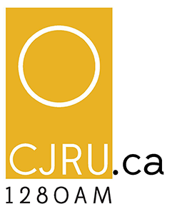
Noah Sniderman
Volunteer Coordinator
volunteer@cjru.ca
416.904.6889

Community Engagement Letter

This winter, CJRU 1280AM ran its first ever 24 Hour Radio Challenge. From February 9th to 10th, participants had 24 hours to write, record and edit a three to six minute radio story, using three secret ingredients announced at the beginning of the challenge. They were provided with equipment, studio time, and sound library, along with video resources on radio production. The goal of CJRU’s 24 Hour Radio Challenge was to inspire Ryerson students and members of the downtown community to learn how to tell their stories through radio/podcast.

Interest in CJRU’s 24 Hour Radio Challenge surpassed all expectations 20 teams signed up for the challenge, representing 31 participants. 18 of the teams were composed of non-volunteers from the community, representing 28 participants. Additionally, eight of the participants reported themselves as being first-time radio producers. Nine teams were able to submit an entry by the deadline, and received feedback from the panel of judges, with the top five pieces getting played on the radio. The prizes for the top three pieces included Izotope’s Neutron, RX 7 Elements and RX 7 Standards, along with studio time at local recording studio, Epilogue Studios.

The pieces were judged by a panel of radio and podcast experts, including Annalise Nielsen, Digital Editor at Frequency Podcast Network (formerly the Senior Podcast Producer, Technical and Editorial at Entertainment One), Dr. Miranda Campbell, host of the Everyday We’re Hustling podcast and assistant professor in Ryerson’s School of Creative Industries, and Paula Letang, host of All About The Funk.

For more information, visit:
Challenge.cjru.ca
Soundcloud.com/scopeatryerson/sets/cjrus-24-hour-radio-challenge-finalists

